Jenkins Task

Launch Jenkins and explore creating projects and users.
- Install Java first, then Jenkins

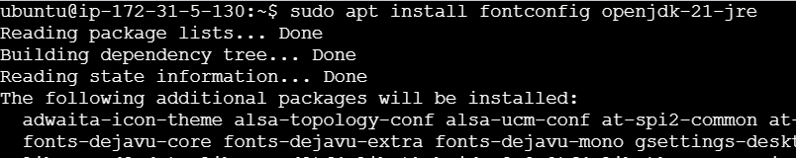

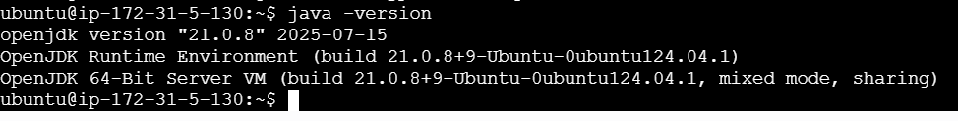

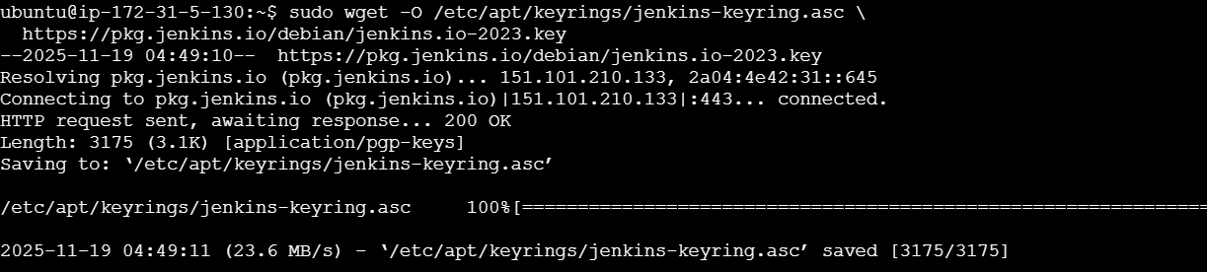

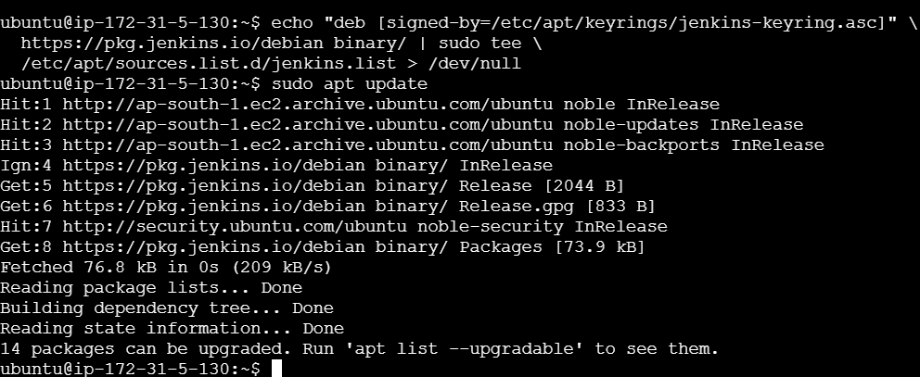
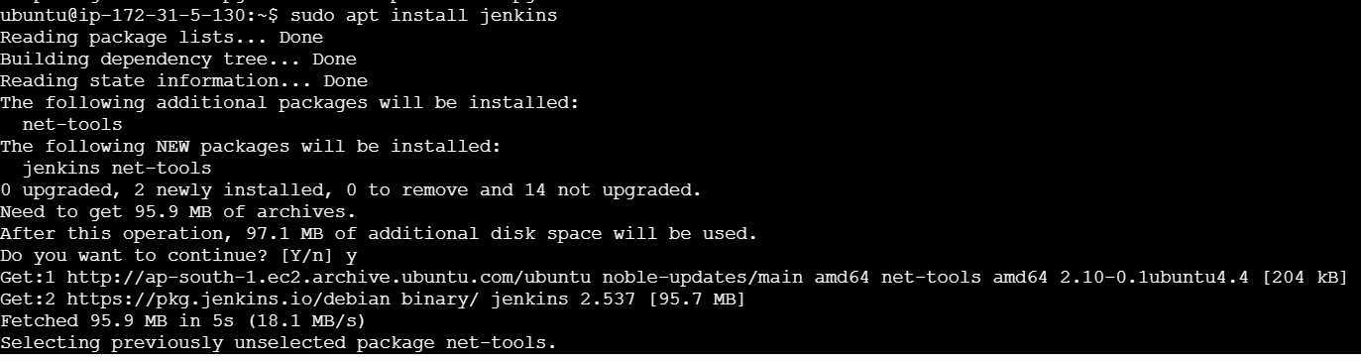
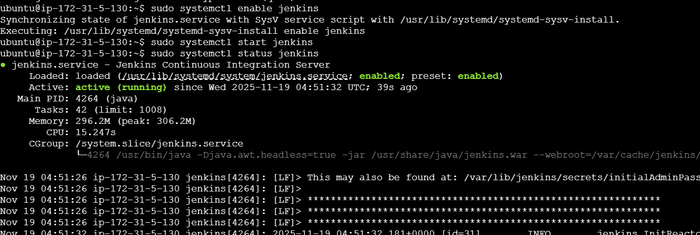
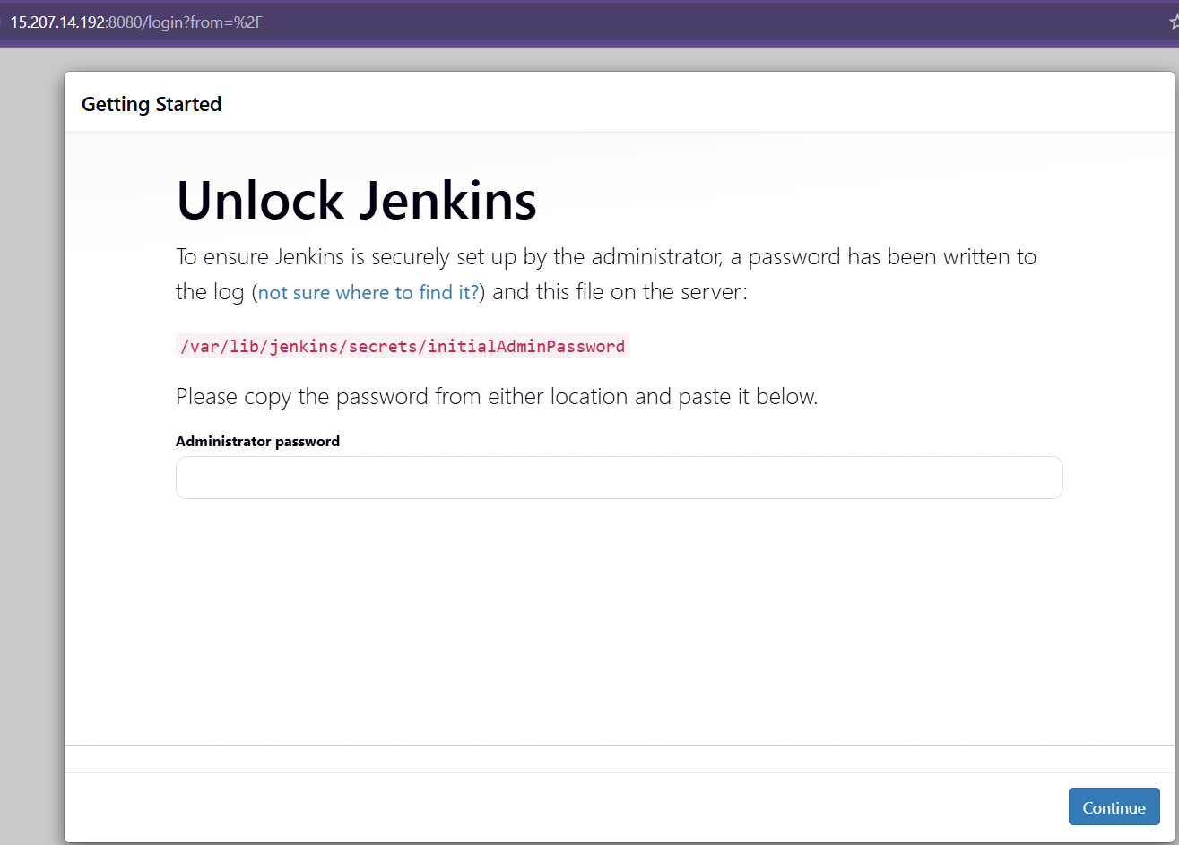

- The command: sudo cat /var/lib/Jenkins/secrets/initialAdminPassword will print the password at the console.

Create Users in Jenkins
Step 1: Install Role-Based Authorization Plugin
Step 2: Enable Role-Based Permissions
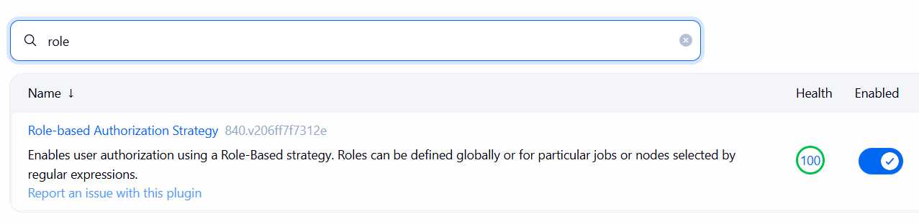
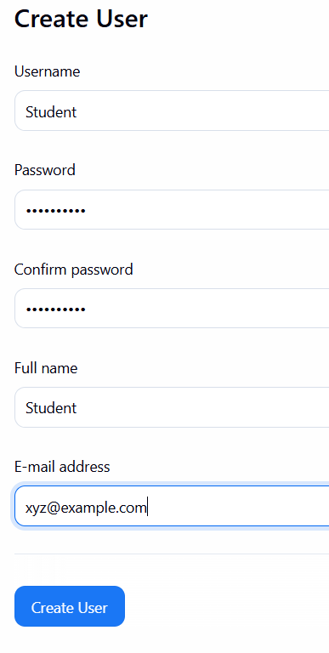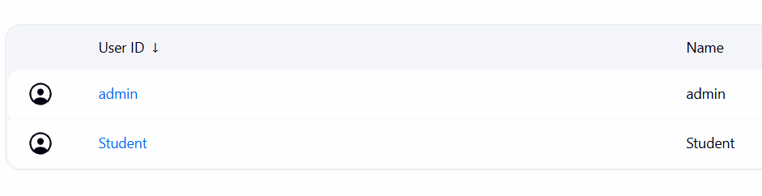

- Assign Roles to Users

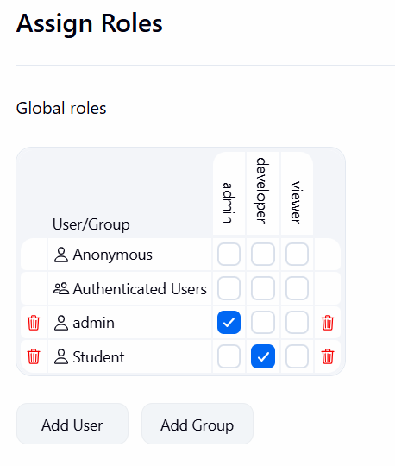

Create a Jenkins Project (Job)

